MAVEN ASSIGNMENT

-Submitted by (Neeraj Kumar Solanki INT444)

1. Install Maven

1. Send the screenshot of "mvn -version"

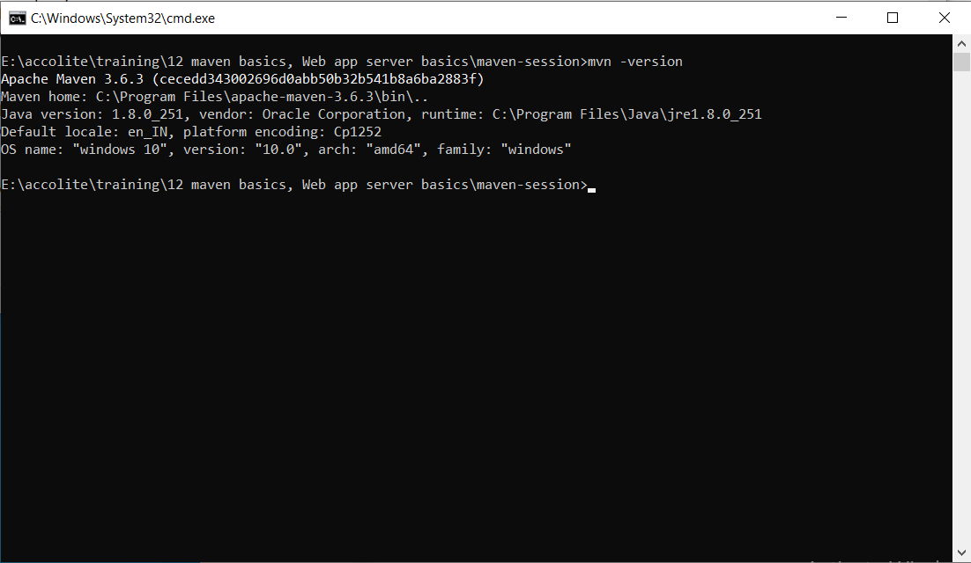

2. Create a sample maven project

1. Using archetype plugin and generate goal.

2. Give custom values for groupId, artifactId, version, package and execute "mvn install" and "mvn exec:java -Dexec.mainClass=your-fully-qualified-class-name".

3. Share zip of project and screenshot for "mvn install" and "mvn exec:java" command

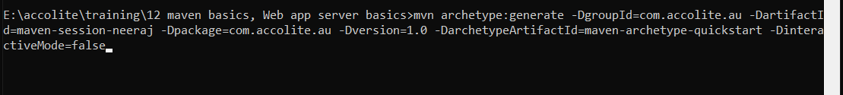

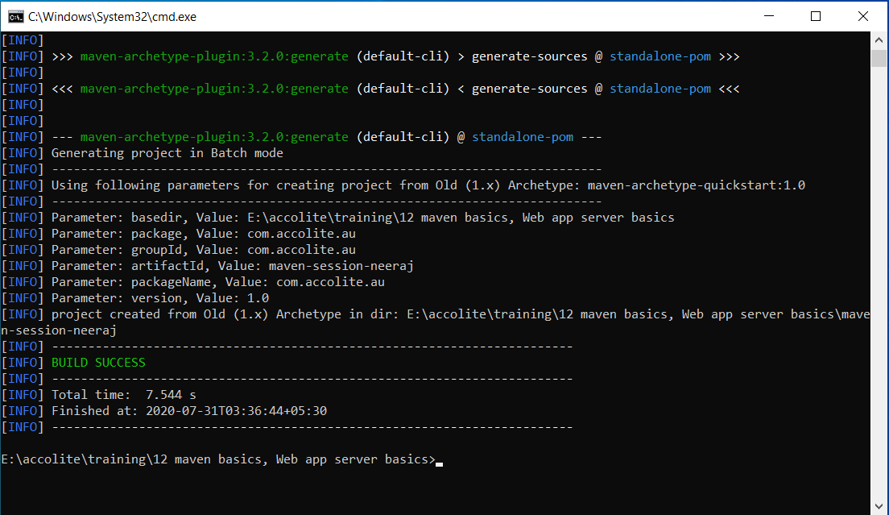

Mvn install

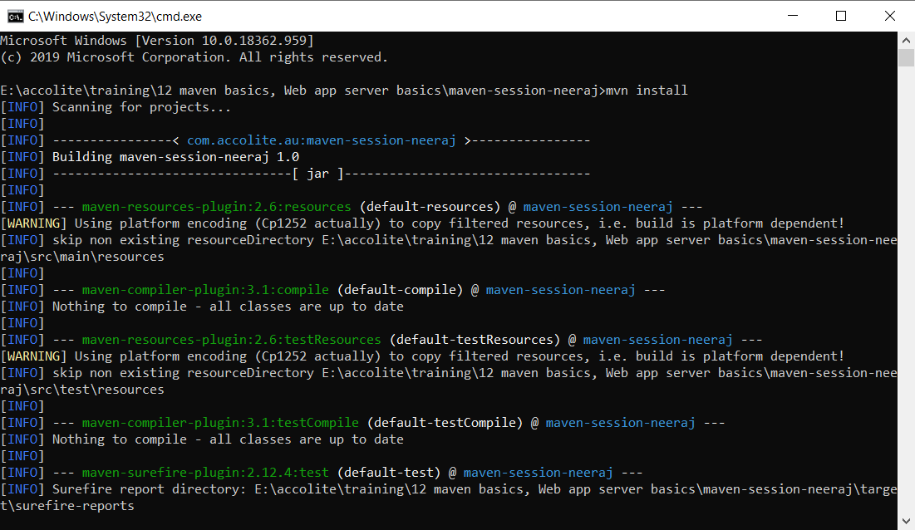

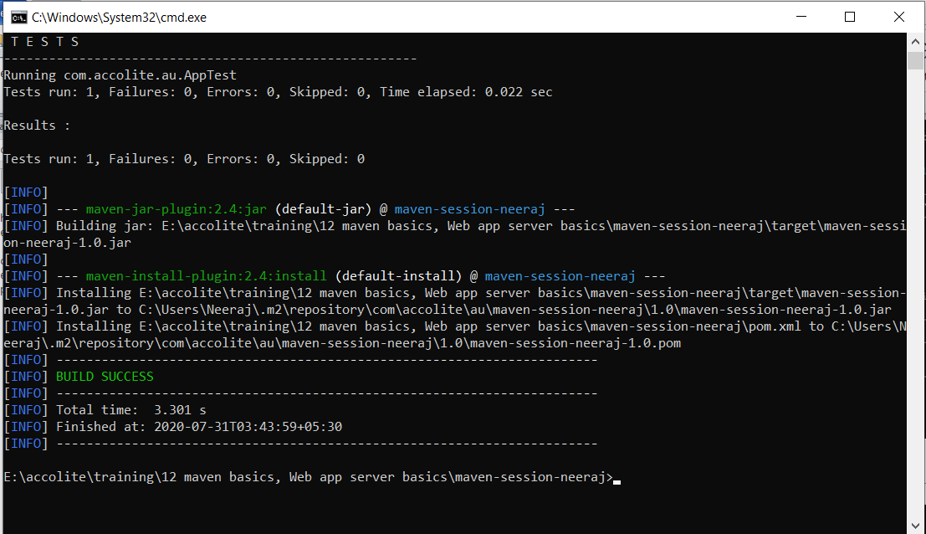

Directory Structure

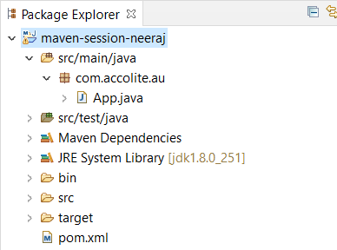

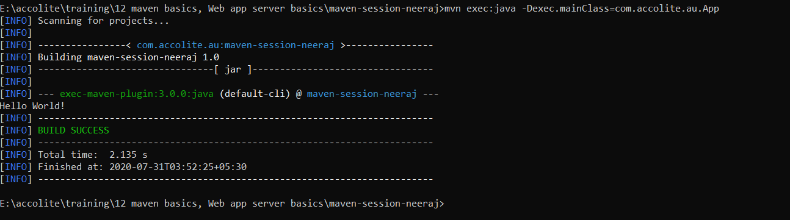

3. Create a maven web-app project

1. Using archetype plugin and generate goal.

2. Give custom values for groupId, artifactId, version, package and execute "mvn install" and "mvn exec:java -Dexec.mainClass=your-fully-qualified-class-name".

3. Share zip of project and screenshot for "mvn install"

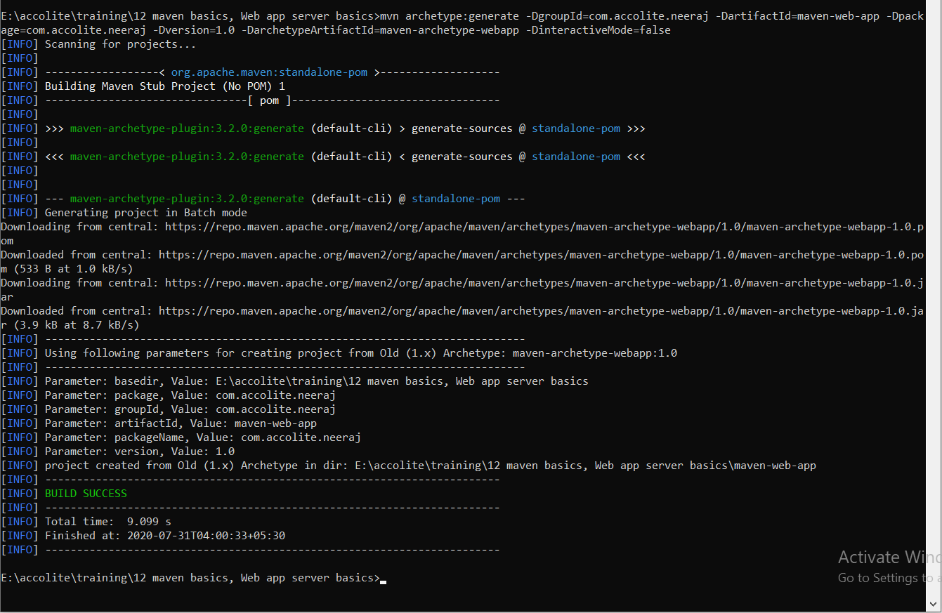

Mvn install

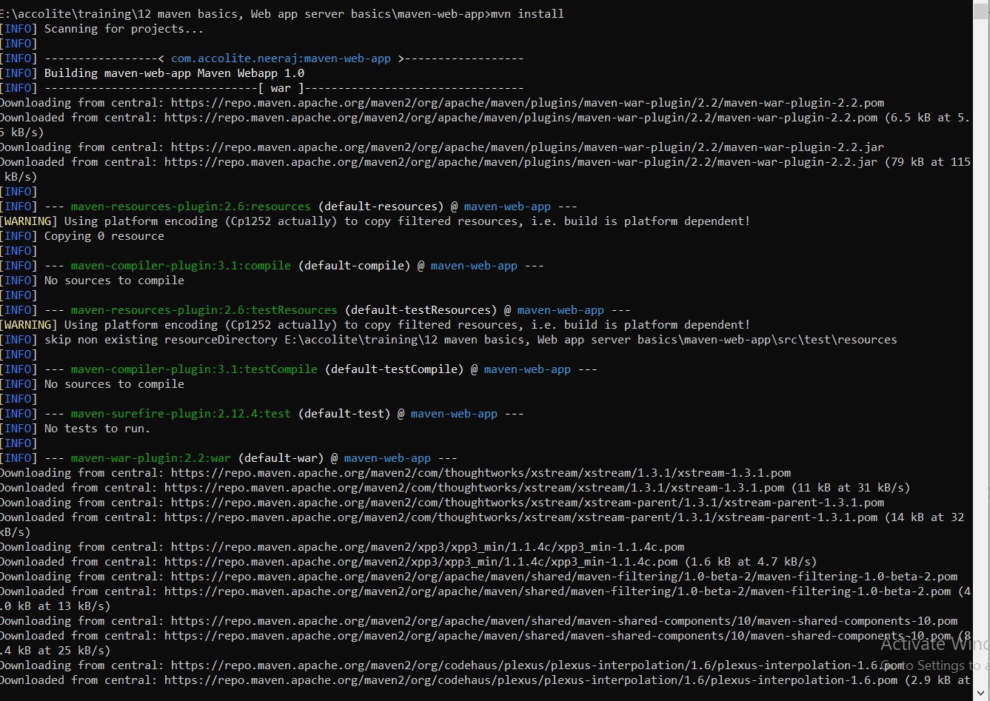

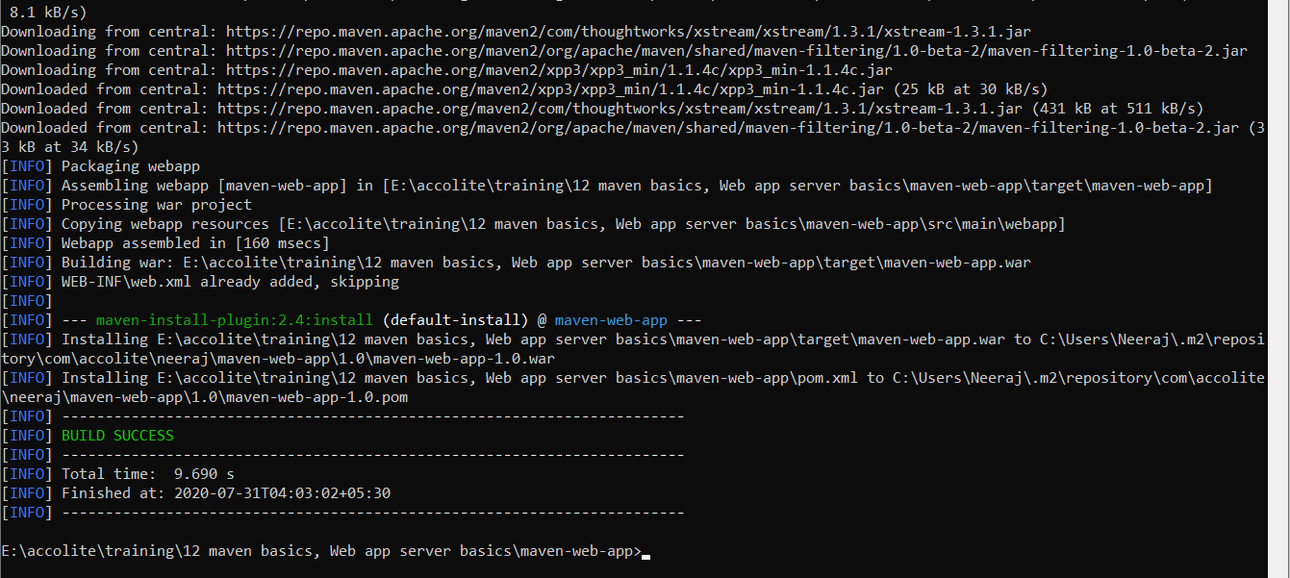

4. In the above created sample maven project (Step 2) run "mvn install" again but it should now skip the execution of tests.

1. Send the screenshot of "mvn install" that should skip the execution of tests.

